**Organisations:**

* Dev.azure.com is the site we need to open to access azure devops.

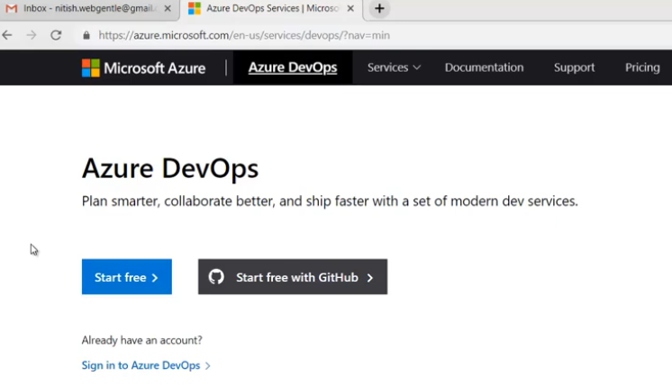

* We can also use github account to login.
* Once we login. It will ask to create a project as below.

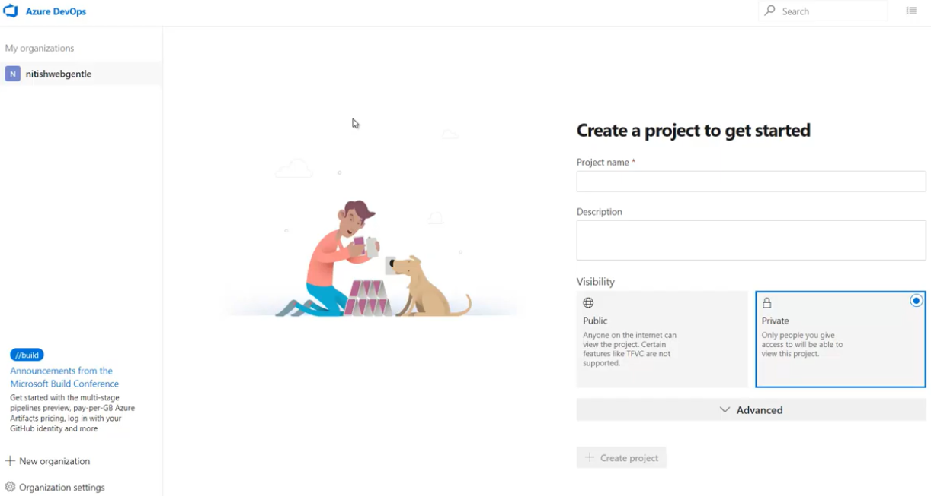

* As above, we can see it created organisation automatically with the email we have given in login
* We can add name, mail ID, change image in profile settings.

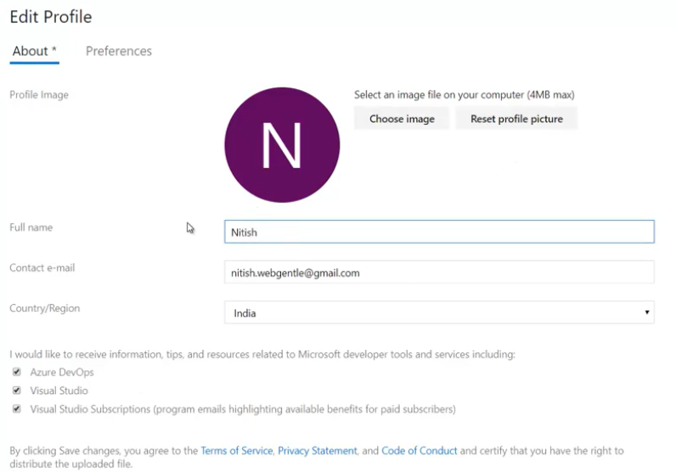

**Organisation in azure devops:**

* Organisation is a collection of groups of projects.
* It is very important. We must have organisation to work with azure devops.
* Organisation name must be unique.

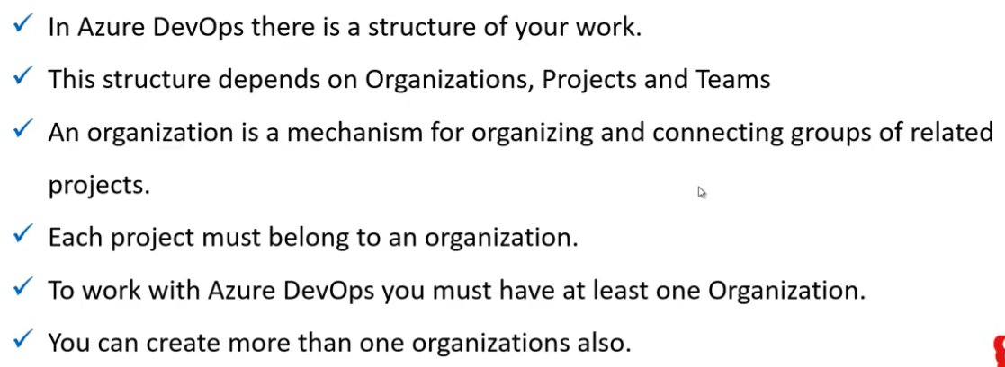

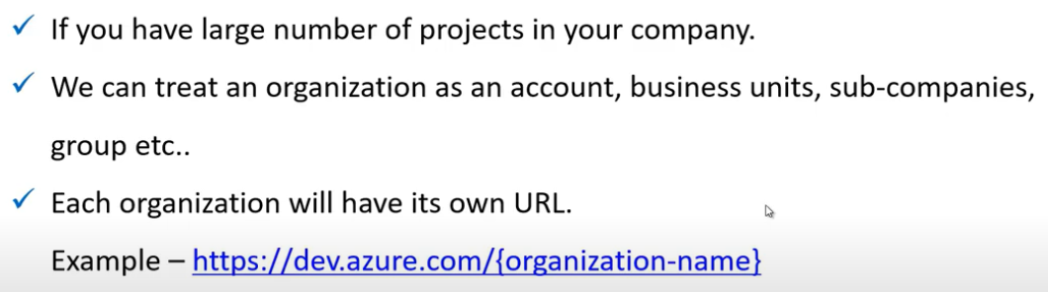

* We can use create organisation option from the downside of the screen and add the name as below.

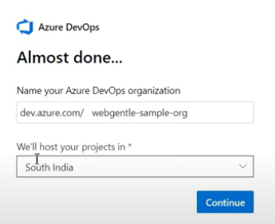

* We also need to select the region for data centre. So that the code, boards or any data we used in azure devops will be stored in nearby data centre.

**Organisation settings:**

**Overview:**

* In organisation overview, we can change the name, add description and also set the time zone as below.

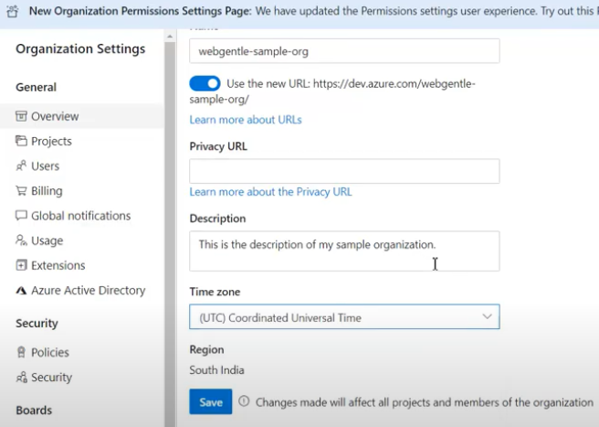

We can also change the owner, delete the organisation as below.

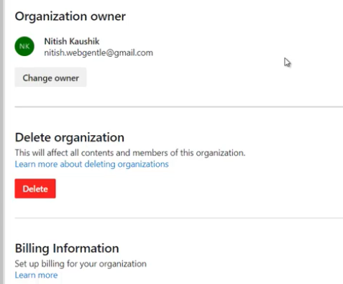

**Projects:**

* We can create new project from here.

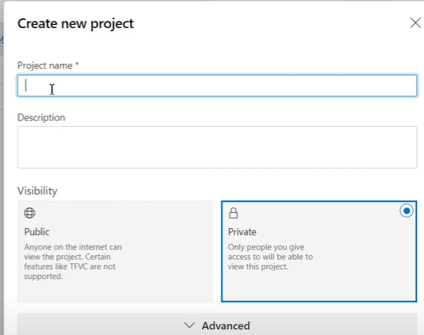

* Once it is created, we can see all the projects here.

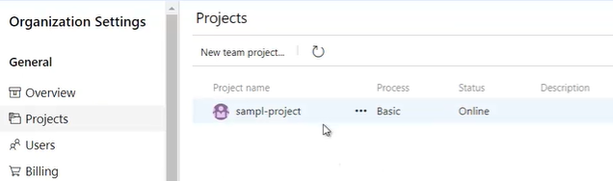

**Users:**

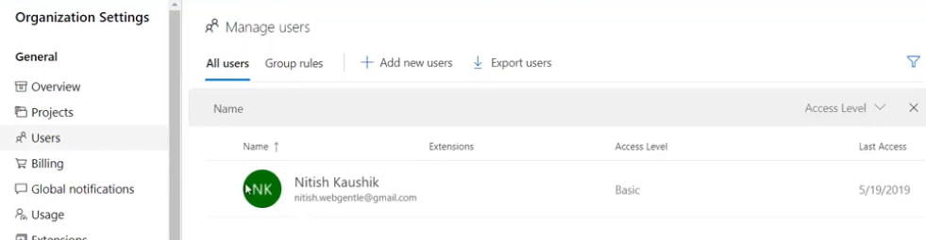

* All the user related info will be here. We can add users.

**Billing:**

* We can see billing information here.

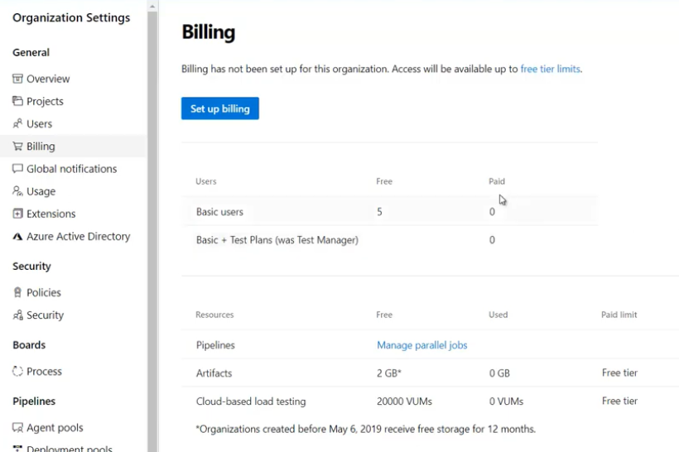

* Azure devops is free for 5 users.

**Extensions:**

* We can install extenstion here to integrate with third party tools here. We can go to marketplace to install them.

**Permissions:**

* Here, we can select user or group and assign the permissions.

**Process:**

* All work process related details will be here.